Technical Design Document: Cinema tickets presale.
My Name- Richard Crespo
Date- January 21, 2026

Program Description
This program simulates a pre-sale system for cinema tickets. A maximum of 20 tickets can be sold in total, and each buyer may purchase up to 4 tickets. The program repeatedly prompts the user for the number of tickets they want to buy, validates the request, updates the remaining ticket count, and tracks how many buyers successfully purchased tickets. The loop continues until all tickets are sold, after which the program displays the total number of buyers.

Functions Used
Function 1: get_ticket_request()
Purpose:
Prompts the user for the number of tickets they want to buy and validates the input.
Details:
- Uses input() to collect user input
- Ensures the number is between 1 and 4
- Repeats until valid input is provided
- Returns the number of tickets requested

Function 2: process_sale(requested, remaining)
The Purpose of it-
Determines whether the requested number of tickets can be sold and updates the remaining ticket count.
Details:
- Uses an if statement to check if enough tickets remain
- If the sale is valid, subtracts from the accumulator (remaining)
- Returns updated ticket count and a Boolean indicating whether the sale succeeded

Additional Program Components
Accumulator Variables
- total_tickets — tracks remaining tickets (starts at 20)
- buyer_count — counts successful buyers
Loop
A loop runs until total_tickets reaches 0.
Input/Output
- Input: number of tickets requested
- Output: remaining tickets, purchase success messages, final buyer count
My results-
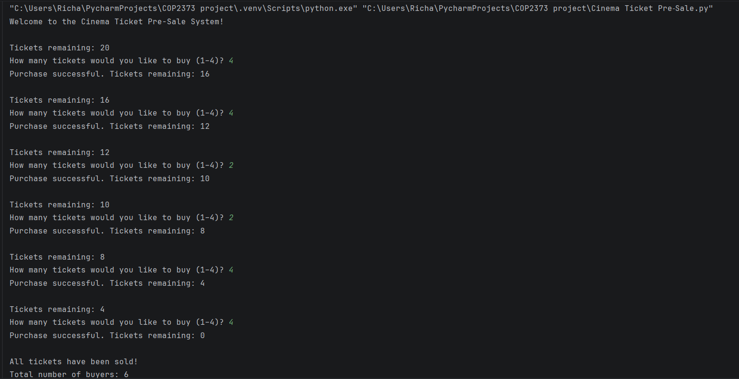
Link to my repository- https://github.com/richardcrespo/COP2373_project/blob/master/Cinema%20Ticket%20Pre%E2%80%91Sale.py

